Performance Oriented Accurately Controlled High-speed Egg-sorting Device (POACHED)

EGG-Sortinaire (EGGS)

Concept of Operations

Tuesday, January 27th 2009

Prepared for
Federated Ring of Integrated Egg Distributors
(FRIED)



Table of Contents

Paragraph Page
Table of Contents 2
1.0 SCOPE 3
1.1 Identification 3
1.2 EGG-Sortinaire Overview 3
1.3 Document Overview 3
2.0 APPLICABLE DOCUMENTS 3
2.1 Project specification 3
2.2 EGG-SORTINAIRE Project Standards 3
3.0 CURRENT PRODUCT OR PRODUCT SITUATION 3
3.1 Current Mission and Scope 4
3.2 Current Product Description 4
3.3 Current Personnel Aspects 4
4.0 OPERATIONAL CONCEPT of the new product 4
4.1 Assumptions 4
4.2 New Mission and Scope 4
4.3 Product Functions 5
4.3.1 States and Modes 5
4.3.2 Operation in Specific States or Modes 5
4.4 Operational Environment 5
4.5 Support Concept 6
4.6 Personnel and Training 6
4.7 Summary of Organizational Impacts 6
4.8 Product Evolution 6
5.0 Performance Characteristics 6
5.1 Key Operational Requirements 6
5.1.1 Mission Critical Capabilities 6
5.1.2 Key Performance Requirements 6
5.1.3 Quality Factors 7
5.2 Measures of Effectiveness (MOEs) 7

TABLE OF FIGURES

Figure 1: State Space Diagram of System 5

Performance Oriented Accurately Controlled High-speed Egg-sorting Device (POACHED)«ProjectName»

EGG-Sortinaire (EGGS)

Concept of Operations

SCOPE

Identification

This document describes the Concept of Operations (CONOPS) for the EGG-Sortinaire (EGGS) system; Version 0.1.

EGG-Sortinaire Overview
The purpose of the product is to provide the user with a portable, efficient system for sorting eggs by size. The product will optimize sorting time, while minimizing egg breakages and checks. In the past, local farmers have manually inspected, sorted, and packaged eggs in the field at each farm stop. This product intends to revolutionize the industry by simplifying this tedious process. It is fast, easy-to-use, and precise. Its portable framework allows it to be easily transported to service each farm site.

Document Overview
The purpose of this Concept of Operations is to collectively organize system information, to define project assumptions, and to explain preliminary system design concepts and operating goals.

APPLICABLE DOCUMENTS
Paragraphs 2.1 through 2.2 list the references that form this document to the extent specified herein. In the event of conflict between the documents referenced herein and the contents of this document, the contents of this specification shall govern.

Project specification
The project specification document is “Portable Egg Sorter Project Rev E7.doc.” The date of this publication is January 5th 2009. This document gives a project overview along with customer requirements.

EGG-SORTINAIRE Project Standards
The Project Standards come from the United States Department of Agriculture. The publication referenced herein is the “United States Standards, Grades, and Weight Classes for Shell Eggs.” The effective date of the document is April 6th 1995.

CURRENT PRODUCT OR PRODUCT SITUATION
The Federated Ring of Integrated Egg Distributors (FRIED) would like a system to be designed by ELDP Solutions that modernizes current egg-sorting systems. Our new product, EGG-Sortinaire (EGGS), looks to modernize the egg-sorting process through the use of automation techniques, speed-driven yet safe egg handling, and a design that allows for fast setup and breakdown times.

Current Mission and Scope
FRIED uses a manual, mobile system to collect and sort eggs from farmers. The current manual egg-sorting process is impractical for the volume of eggs that the farmers produce. Too much time is being spent on manually sorting eggs based on class/size with the current implementation. The EGGS system removes the high overhead caused by manually sorting eggs, providing a time-efficient and profitable solution to the issue at hand.

Current Product Description
The FRIED organization travels in their mobile processing and packing van to different member farms. Once on site, they inspect, sort, and box the eggs for immediate distribution. The current system for egg-sorting is fully manual in nature.

Current Personnel Aspects
The majority of the current users are local farmers running small family-owned businesses. The inefficient sorting techniques require FRIED members to perform sorting and packaging tasks on an overwhelmingly increasing volume of eggs. New farmers must be trained in the technique, which can cause setbacks in time and finances. The current sorting method is highly subjective amongst varying egg sorters and may lead to inconsistencies in sorting patterns.

OPERATIONAL CONCEPT of the new product

Assumptions
- TBD references herein will be resolved with customer clarifications.
- The input and output interfaces are identical across all farms being serviced by FRIED.
- In the farm field environment, we assume there will be an area where our product can operate on a completely flat area.
- Our system will operate in an enclosed farm structure that is not susceptible to any environmental hazards such as adverse weather conditions.
- All users of EGG-Sortinaire (EGGS) have been properly trained to operate our system.

New Mission and Scope
The goal of EGGS is to modernize the current implementation of egg-sorting used by the Federated Ring of Integrated Egg Distributors (FRIED). EGGS looks to eliminate the manual classification effort and replace it with an automated and faster egg-sorting system. Focusing on the family farmer, efficiency, ease of mobility, and a simple operator interface are critical factors that will be incorporated into our desi

Product Functions
The EGGS autonomously sorts eggs by weight. Eggs will be manually placed onto the EGGS platform at a user-variable rate, allowing the sorting process to begin. Once an egg is successfully classified, our system drops it into its corresponding bin for packaging.

States and Modes
EGG-Sortinaire can operate in a series of modes as shown in the diagram below:
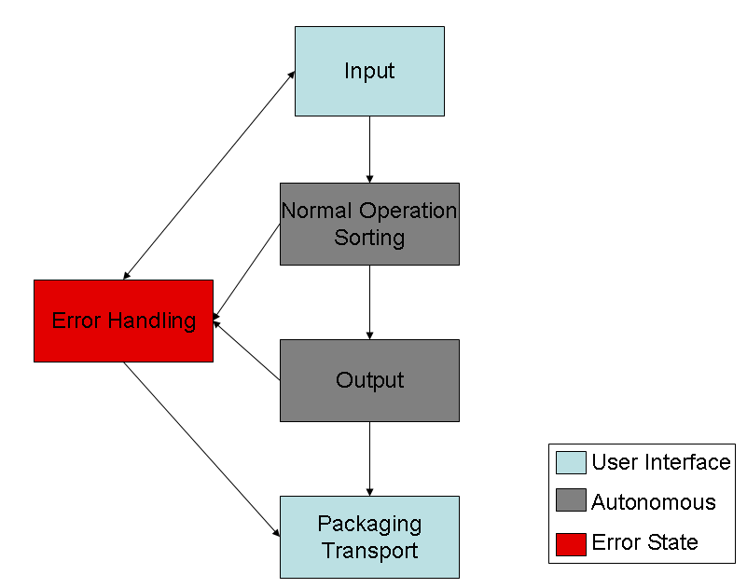

Figure 1: State Space Diagram of System

Operation in Specific States or Modes

Input Stage: The user manually places an egg onto the EGGS platform.
Normal Operation / Sorting: EGGS sorts the egg presently loaded.
Output: Takes sorted eggs from system and places them into appropriate weight bins
Packaging/Transport: Eggs are packaged into cartons. Device is disassembled and transported.

Operational Environment
EGGS will operate in an indoor, farm environment on an even surface at room temperature.

Support Concept
All EGGS systems come with a three-year maintenance warranty. A troubleshooting hotline and regional-based support will be available should any problems arise with EGGS.

Personnel and Training
Typical users of EGGS are members of the FRIED organization. Training will be minimal and simple, encompassing proper techniques for the setup, debugging, operation, breakdown, and transport of EGGS. No previous education or training is required.

Summary of Organizational Impacts
The current input system will remain manual. The result of having one or many of our machines is that it will significantly reduce the manual labor required in sorting eggs. Minimal, additional training may be required. EGGS offers an easy transition from the current FRIED packaging system to the newly implemented output system. EGGS users must allow sufficient vehicle space to meet system dimensions

Product Evolution

Future evolution of our product will provide the following enhancements:

- Sorting support for all USDA egg sizes
- Routing, timed input system to multiple EGGS machines
  - Horizontal parallelization
  - Variable speed selection
- Weather resistance
- Accessories
  - Built-in light for candling
  - Digital Counter
  - Washing attachment to output system

Performance Characteristics

Key Operational Requirements

Mission Critical Capabilities
The device will have provision for protection measures such that if an egg drops from either the sorter or the handler, it will not soil the floor.

Key Performance Requirements
EGGS will process eggs at a speed of 500 eggs per hour (eph) or greater while limiting breakage to 5 % and checking to 5 %. The system will also count the number of eggs processed.

Quality Factors
The device will work in a farm field environment.

On-site setup time will be no longer than 5 minutes.

The site breakdown and packing time will be no longer than 8 minutes.

Normal post-operation cleaning (if any is required) will be included when calculating breakdown and packing time.

The device must be easily portable by one person; therefore, the device will weigh less than 20 pounds (lbs).

Measures of Effectiveness (MOEs)
Measures of effectiveness that will be used to gauge system success are as follows:
- Number eggs sorted per hour (eph)
- Breakage and checking rates
- Egg sorting accuracy
- Setup, breakdown and cleanup time

